How to run TrafficSystem.jar

1. Install JDK(Java Development Kit) for windows. <https://www.oracle.com/technetwork/java/javase/downloads/jdk8-downloads-2133151.html>

C:\Users\Jen\Desktop\Docu\Capture1.PNG

Located in JavaInstaller folder for 64 bit windows. For 32 bit windows please download the installer in the link provided.

1. Install MySQL Server. <https://dev.mysql.com/downloads/installer/>



Configuring mysql installer

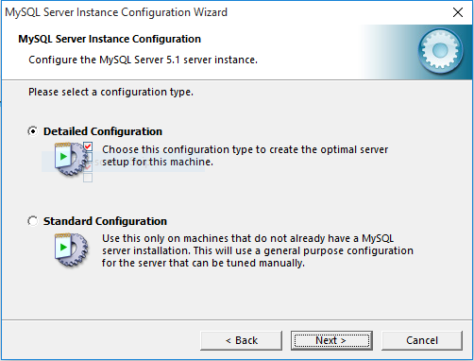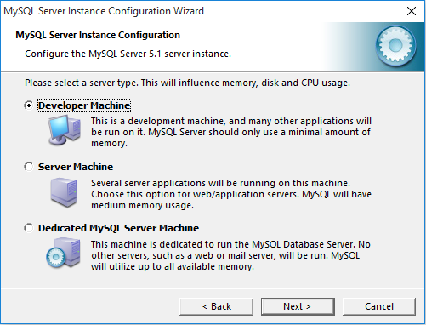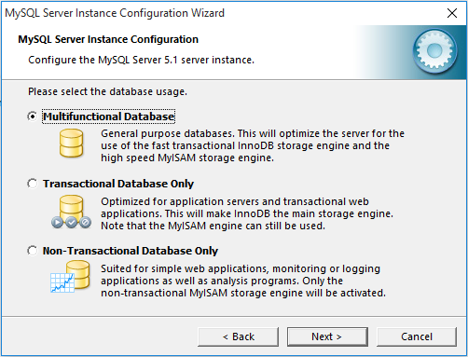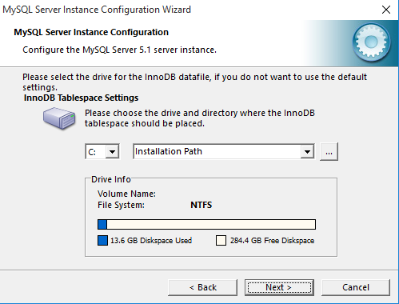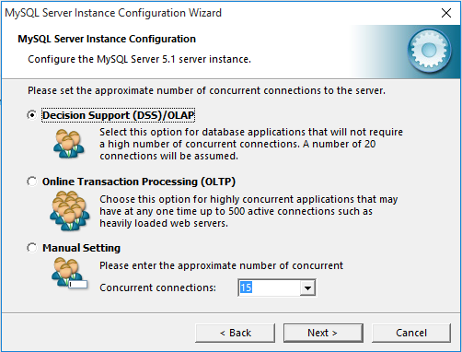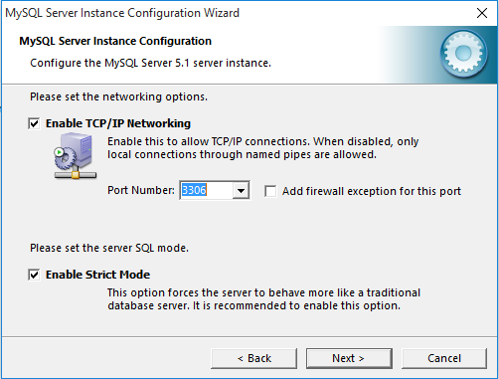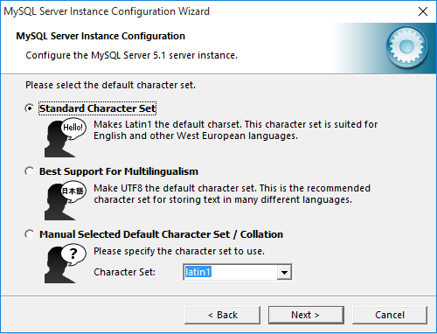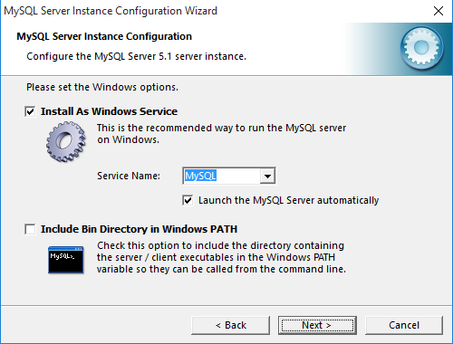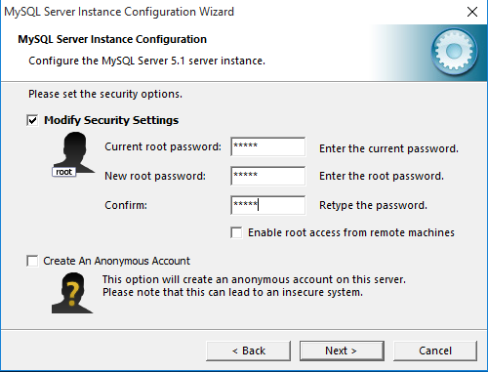

Password: admin

1. Install HeidiSql.



1. Open the file TrafficManagement>dist then open TrafficManagement.jar.

C:\Users\Jen\AppData\Local\Microsoft\Windows\INetCache\Content.Word\Capture5.png

Create shortcut and send to desktop.

Project Description

3 state of the program

* Logout
* Login
* Admin

Logout

* Is only for viewing of all schedule and report.

Login

* Can add, edit, and delete schedule.
* Can add, edit, and delete location.
* Can only view users own inputted record.

Admin

* Can add, edit, and delete schedule.
* Can add, edit, and delete location.
* Can view all record and report.
* Can block/unblock user

Wig Presentation Button

* Video player that plays video at full screen. For coordination meeting presentation.
* Can be close with esc key or alt+f4

Main ScreenAdd Schedule

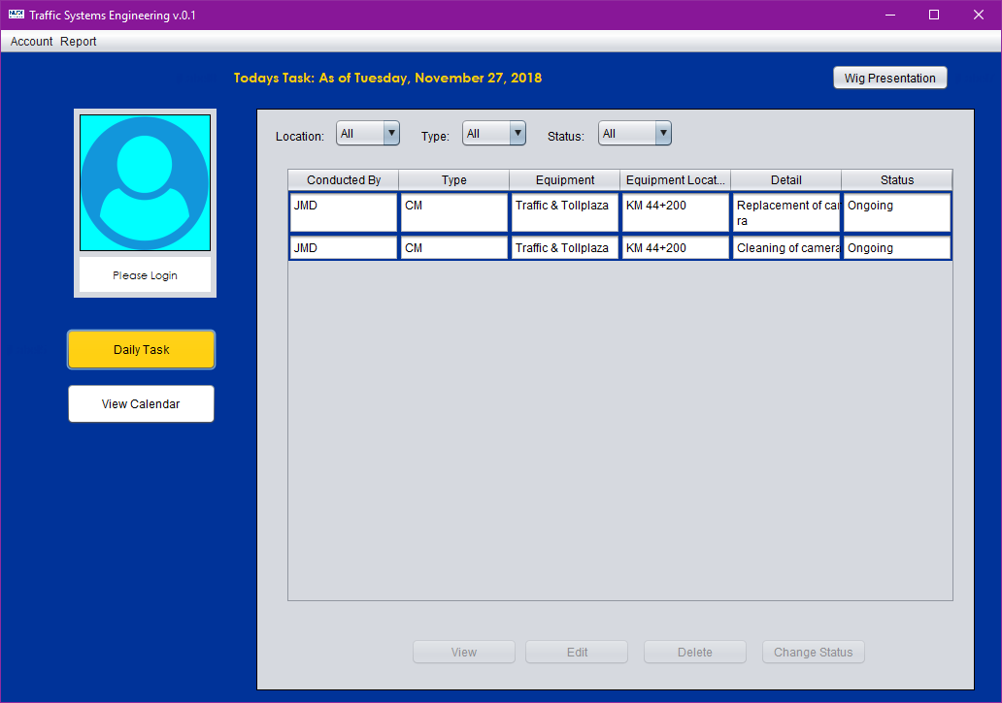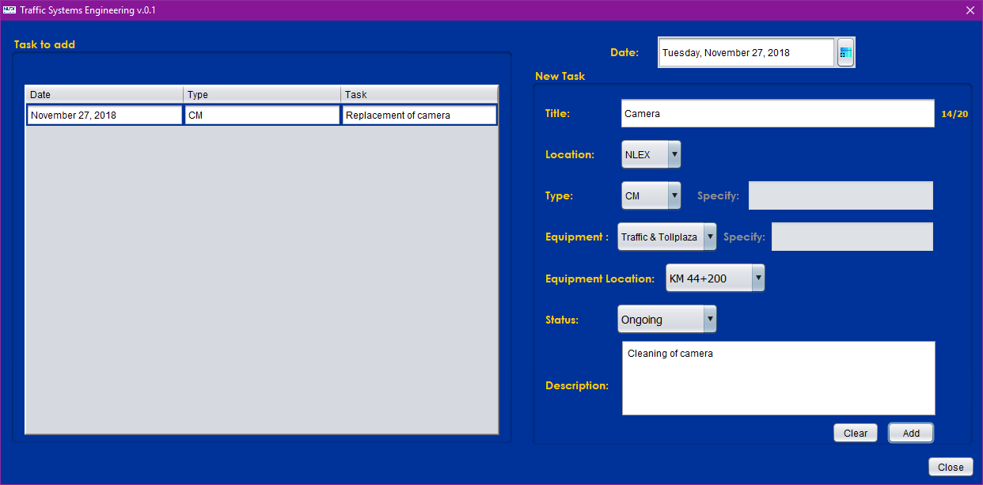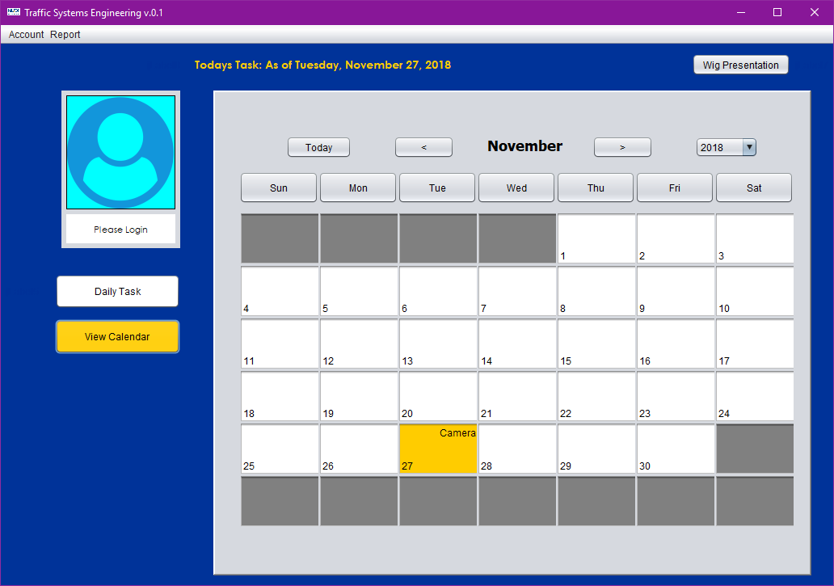

Calendar View. Click calendar to open modification bar.Monthly schedule list

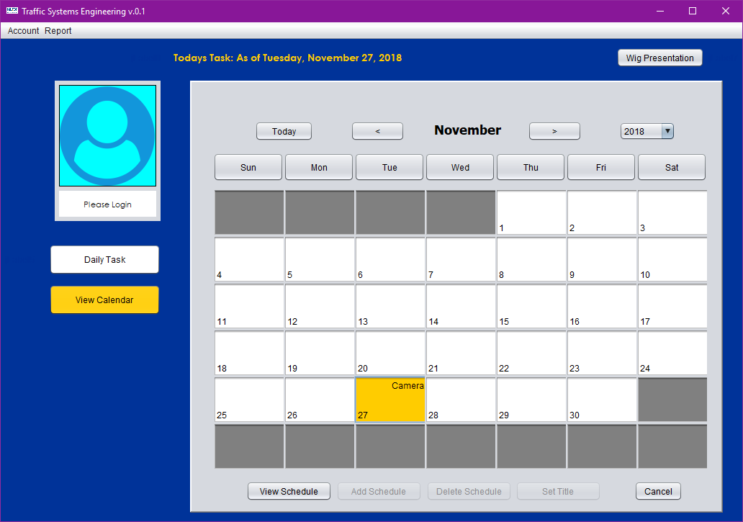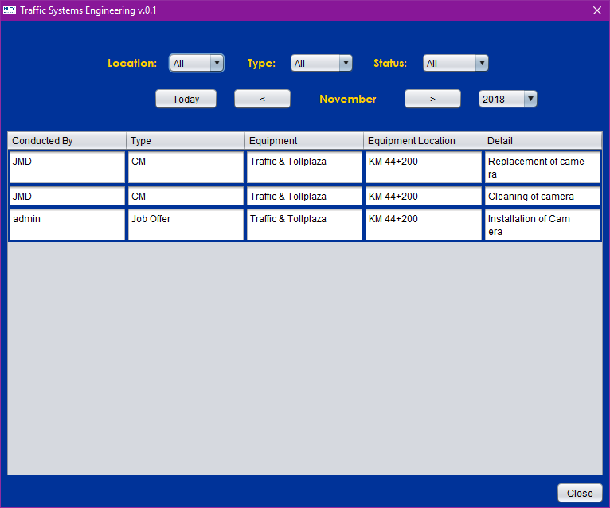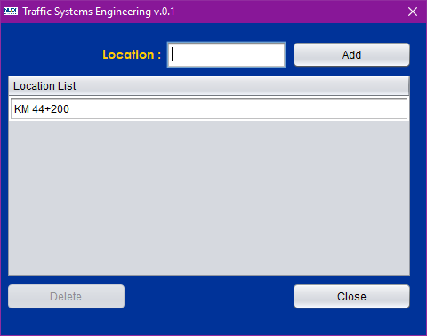

Add/Delete Location